UBND THÀNH PHỐ HỒ CHÍ MINH | CỘNG HÒA XÃ HỘI CHỦ NGHĨA VIỆT NAM
TRƯỜNG CAO ĐẲNG LÝ TỰ TRỌNG | Độc lập - Tự do - Hạnh phúc
THÀNH PHỐ HỒ CHÍ MINH
ĐỀ THI KẾT THÚC HỌC PHẦN LÝ THUYẾT
HỌC KỲ: I NĂM HỌC: 2017 – 2018

Bậc đào tạo: TRUNG CẤP Học phần: NGHE 1
Lớp: 17T4-………… Ngày thi: ___ / ___ / 2017
Thời gian thi: 60 phút (không kể thời gian phát đề)

HỌ VÀ TÊN SV |  | Chữ ký Giám thị I | Chữ ký Giám thị II | Số mật mã
LỚP | SỐ KÝ DANH | Chữ ký Giám thị I | Chữ ký Giám thị II | Số mật mã
--------------------------------------------------------------------------------------------------------------------------
Chữ ký Giám khảo I | Chữ ký Giám khảo II | ĐIỂM BÀI THI |  | Số mật mã
 |  | (bằng số) | (bằng chữ)
1. Hướng dẫn làm bài
Đề số 002

Thí sinh không được sử dụng tài liệu khi làm bài.
Sinh viên làm bài ngay trên đề thi.
Bài thi này gồm 40 câu, mỗi câu 0.25 điểm.

2. Nội dung đề thi

Task 1: You will hear about the inventions. Circle the reasons for them. Listen two times. (1.5ps)(act, u.15, B)

- a. It was a children’s game. 4. a. There were no more cups.
b. It was a fortune-telling game. b. People wanted to eat while they walked.
2. a. They were a joke. 5. a. People wanted to take drinks home.
b. A custom wanted fast food. b. A rich man didn’t want to get sick.
3. a. It was made for tall buildings. 6. a. The inventor wanted to walk faster.
b. It was made for a king. b. The inventor wanted to help his father.

--------------------------------------------------------------------------------------------------------------------------------------------------
Task 2: Listen to the story of the stonecutter. What is the main idea of each part of the story?
Number the statements from 1 to 4. Listen three times. (1p) (act, u16,task2, A)
_____The stonecutter was too busy, and he was tired. He asked the genie to make him a rich man.
_____The stone cutter saw a man building a stone house. He understood that he didn’t need money and power to be happy.
_____The stonecutter lived with his wife in a small house. They were poor but happy.
_____The stonecutter found a genie in a magic lamp. He asked the genie to make him a prince.
Task 3: Circle the correct answers. Listen three times. (1p) (act, u16,expan 4, B)
- India has 3. Aryabhatta invented
- two national languages. a. the number zero.
- twenty-two national languages. b. the soccer ball.

- Many Indians don’t eat 4. Indian movies often show
- beef. a. special effects and good jokes.
- mangoes. b. fighting and dancing

Task 3:
1. a. the guests 5. a. a guest
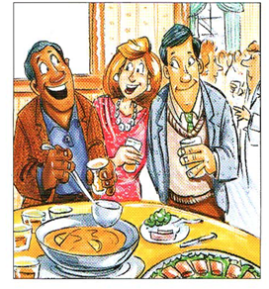
b. the music b. the party
c. friends c. the food

2. a. a guest 6. a. a job
b. the music b. a vacation
c. Jim c. friends

3. a. the music 7. a. the guests
b. a guest b. her new job
c. an old friend c. family

4. a. school 8. a. family
b. the man’s health b. the food
c. work c. the guests

---------------------------------------------------------------------------------------------------------------------------------------
Task 5: Listen. Listen and decide whether the following statements are True (T) or False (F).
Listen three times. (2ps)(tac, u15,task4)
- _____ a. She wants to buy a cheap stereo. 3. _____ a. She doesn’t have very many books yet.
_____ b. She wants a large sofa. _____ b. She has enough money to buy a stereo.

- _____ a. He wants to find a bigger bookshelf. 4._____ a. He’s waiting for the new TV models.
_____ b. He wants to find a cheaper dinner table. _____ b. He bought a dinner table last week.

Task 6: Listen to people talking about cities. Circle what each person say about each place.
Listen three times. (2ps) (act, u23,task 3.2)
- a. There aren’t many interesting places to visit. 5. a. It’s pretty small and quiet.
b. There is a lot to do. b. It’s crowded and noisy.
- a. People are noisy in the street. 6. a. It’s not a pretty city.
b. It’s nice and quiet. b. The scenery is beautiful.

- a. The air isn’t clean. 7. a. It’s good for families.
b. The streets are not crowded. b. It’s dangerous.

- a. Everything is cheap. 8. a. It’s a small city.
b. Everything is expensive. b. It has great nightlife.

----------------------------------------------------------------------------------------------------------------------------------------

Task 7: These people are asking about the weather. What will they wear or take with them?
Listen and check the correct picture. Listen three times. (1.5p) (act, u17,task 3)
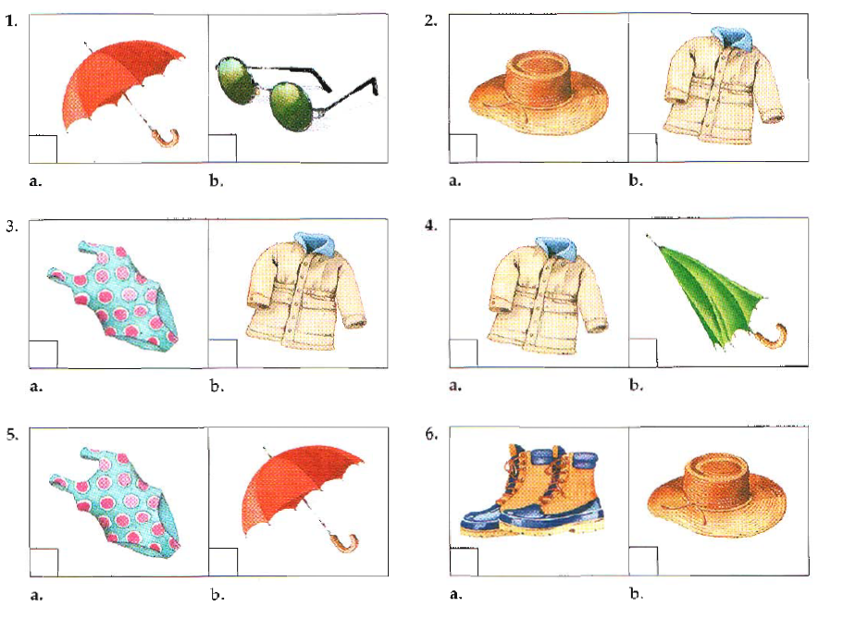
______Hết_______
GHI CHÚ: CÁN BỘ COI THI KHÔNG ĐƯỢC GIẢI THÍCH GÌ THÊM.

TRƯỞNG KHOA TRƯỞNG BỘ MÔN GIẢNG VIÊN RA ĐỀ

Trần Kim Thu Liễu Nguyễn Thị Bảo Trân

